Staples Advantage – Online Printing step-by-step instructions:

Please note that print and copy jobs must be completed online to receive the best discounts.

Before you can use staples advantage discounts, you must be set up with an online profile with Staples Advantage; please email ihfra@ihfra.org to do that.

Step 1: go to www.staplesadvantage.com and login with your username and password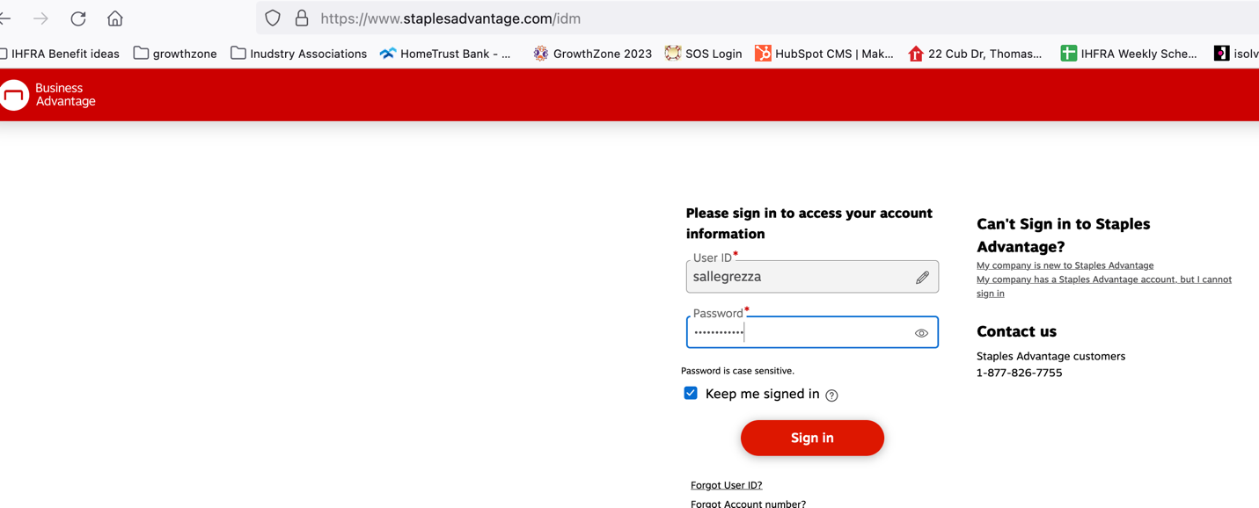

Step 2. On the Top left menu bar, click on the Services dropdown, and click on “Print and Marketing”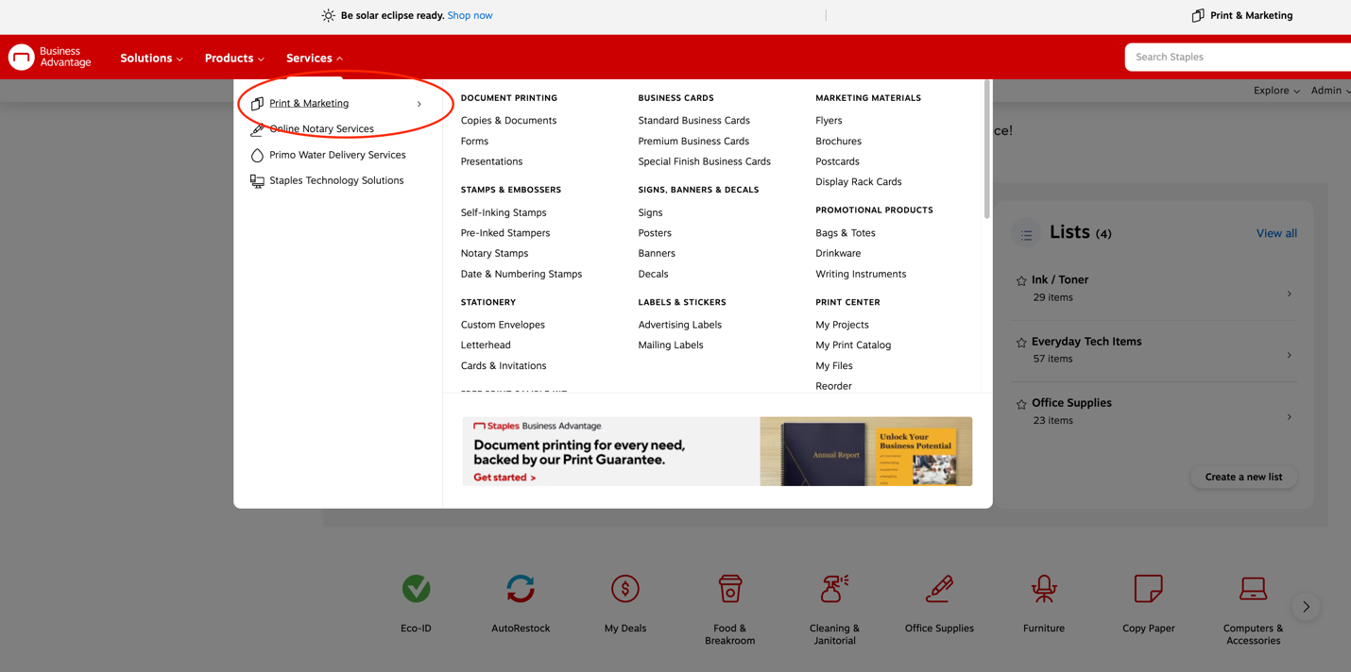
This will take you to the Print and Marketing Services page, where you can select the kind of print and copy services you are wishing to complete.

For most print and copy jobs, you can scroll down and find “Same-Day Printing” under the services section.
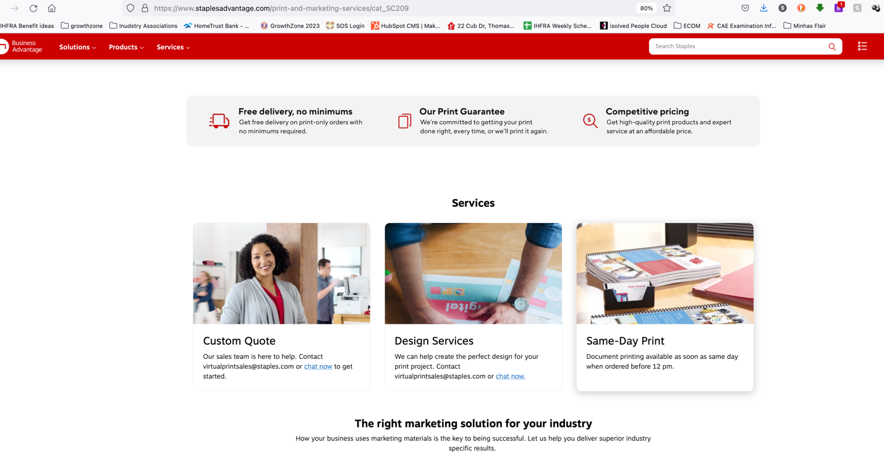
Step 3. Select Same-Day Print

This will take you to the Document Printing home page. A shortcut to this page can be found here: https://www.staplesadvantage.com/document-printing/cat_CG500200

Step 4. Select the Print Job that makes the most sense for you. 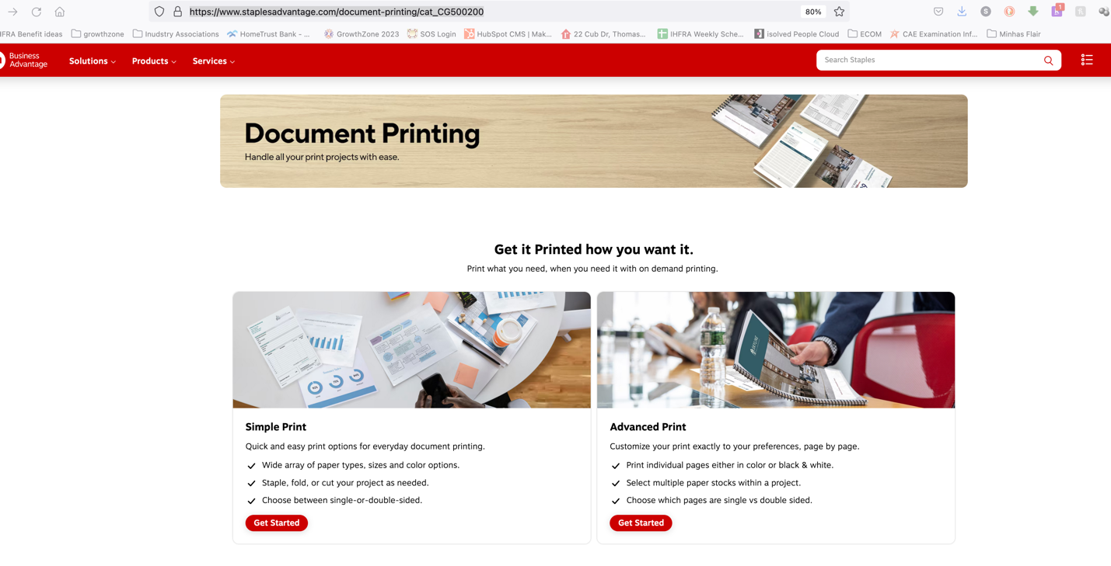

Step 5. You will now be taken to the print project “Customization” section.
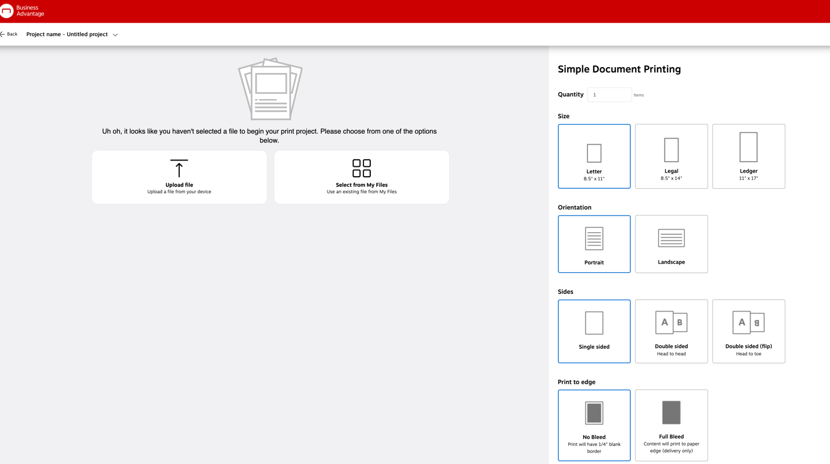

Step 6. From you computer, tablet or mobile device, select the file or files you would like to print. You can select “Upload file” or “Select from my files”

Step 6a. If you select “Upload file” a box will appear and you can DRAG AND DROP your files into this box, or click on the “Browse files” button to find the files manually. 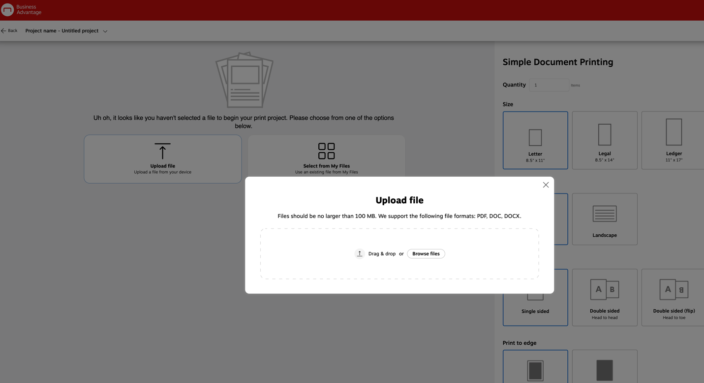

Step 6b. IF you have already uploaded files into your staples account, you can choose the “Select from My Files” option to select a file already uploaded to your Staples Business Advantage account. Again, this option only works if you’ve already uploaded and saved files to your StaplesAdvantage Account.
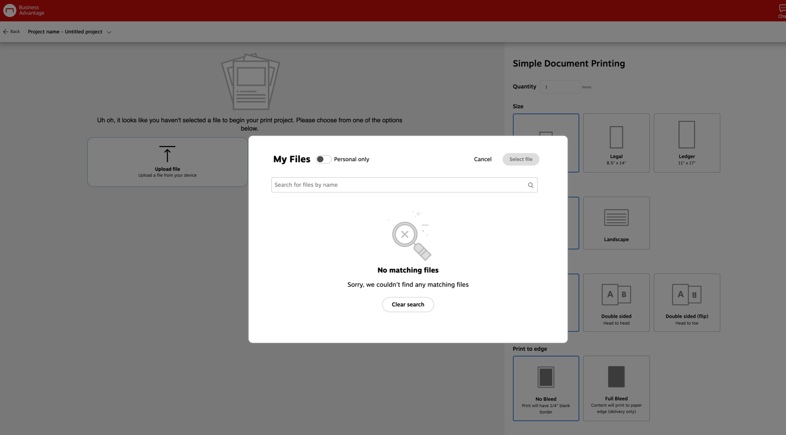

Step 7. Once you’ve uploaded the files you want to print, you can now customize the print job. For example, you can choose the Quantity you need, the type of paper, color or B&W, etc.
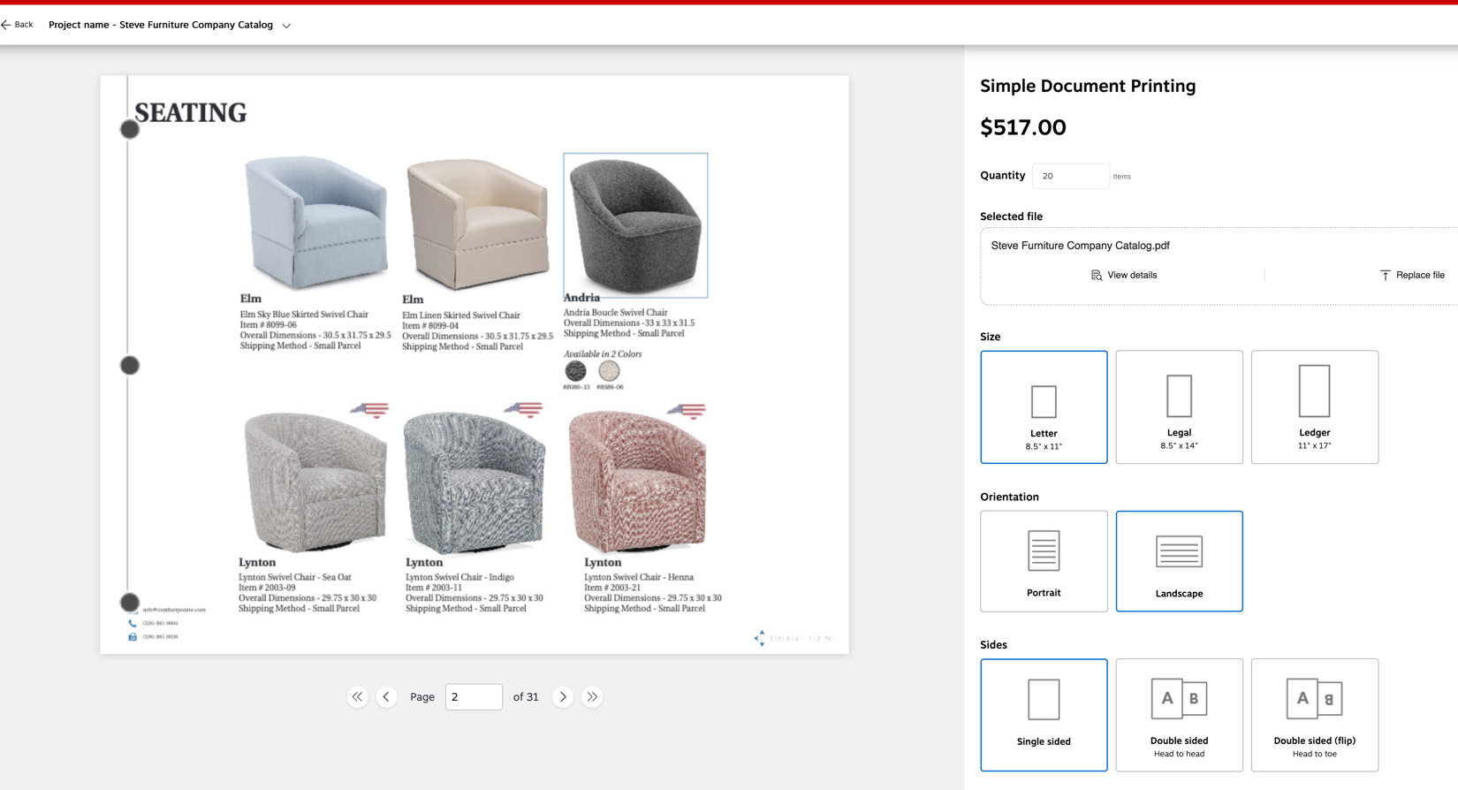

Step 8. Be sure to choose the correct Fulfillment method for you. Most basic print jobs can be picked up in store, but if you require specialty paper or advanced printing options, please note that delivery may be the only option available.
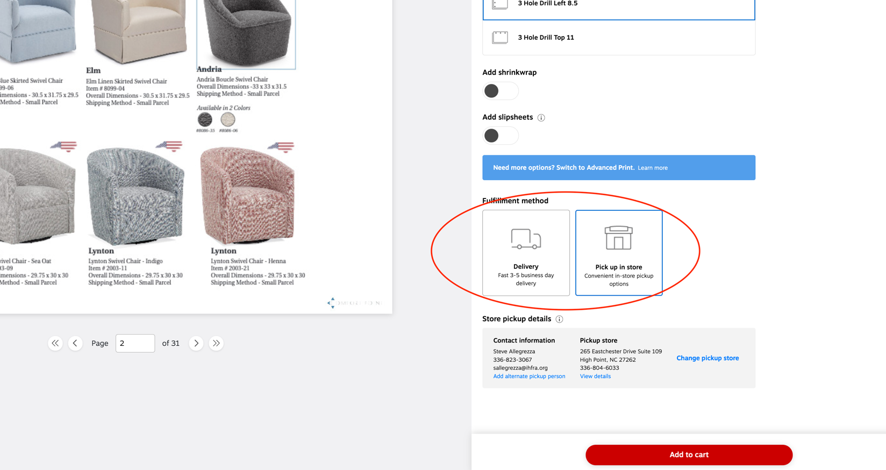

Step 9. Once you’re satisfied with your selections, you can select “Add to Cart”

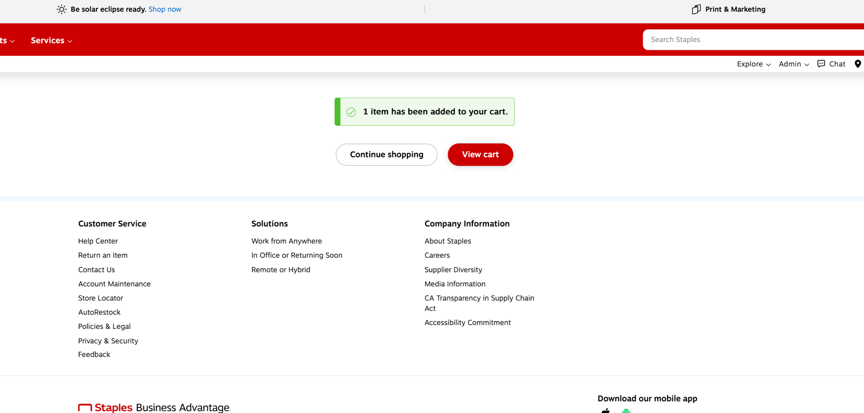

Step 10: Select View Cart if you’re ready to check out, or select Continue Shopping if you need to make additional purchases.

Step 11: Review your order and Check Out. Note: pay careful attention to the fulfillment method for the items in your cart to ensure you’ve selected your desired preference.
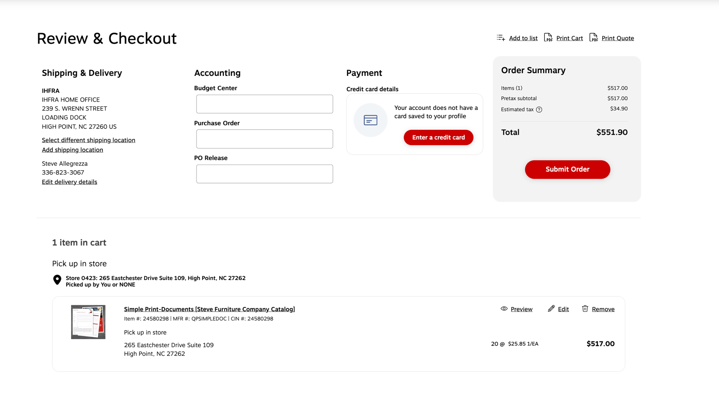

Additional Resources:

Staples Video Tutorial: https://share.vidyard.com/watch/MeZ7FUVtVBgTFvSbdKtSwg

